**Formal Methods In Software Engineering (SE-306-A)**



**Stage – (OCL Research)**

Project Title:

**University Smart Bus & Route Management System**

Submitted by:

**Maida Kosser (221400091)**

**Zoya Khalid (221400095)**

**Muhammad Asad Ullah (221400089)**

**Muhammad Noman (221400087)**

Submitted to:

**Mam Sajiya Tariq**

**BS Software Engineering (VI)**

**GIFT University, Gujranwala**

**Task – 1: OCL Diagram**

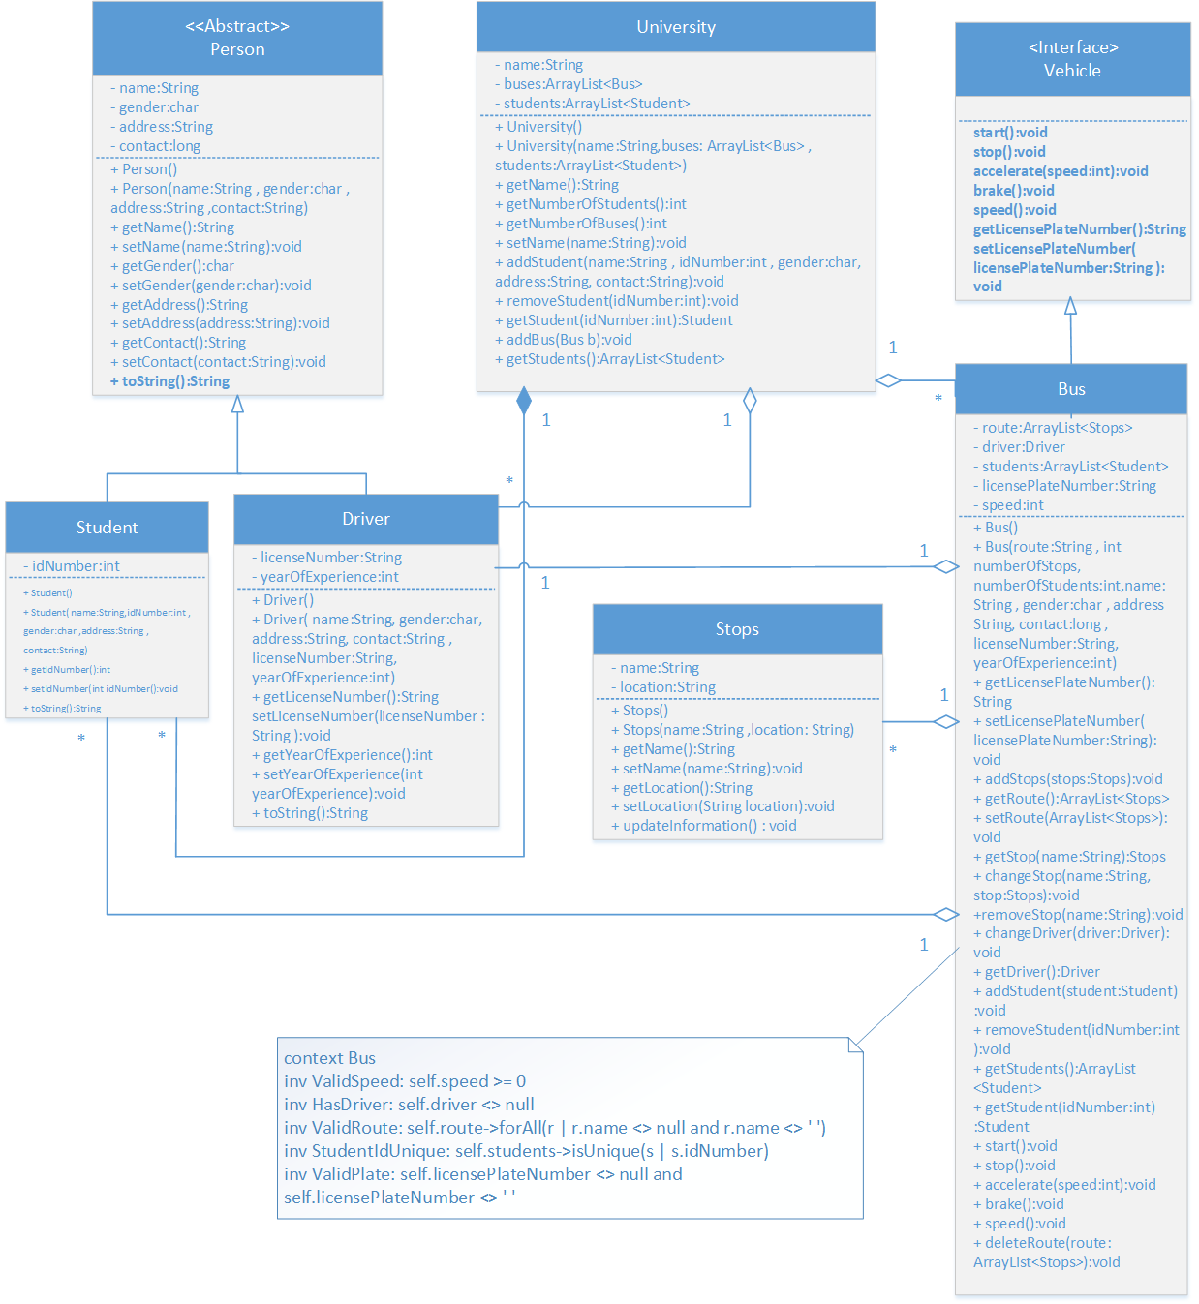

**Member 1: Maida Kosser – Class Bus**

**Task – 2: OCL Code:**

**context Bus**

**Invarients:**

inv ValidSpeed: self.speed >= 0

inv HasDriver: self.driver <> null

inv ValidRoute: self.route->forAll(r | r.name <> null and r.name <> '')

inv StudentIdUnique: self.students->isUnique(s | s.idNumber)

**Pre/Post Conditions for Operations:**

context Bus::addStops(stop: Stops)

pre: StopNotNull: stop <> null

post: StopAdded: self.route->includes(stop)

context Bus::changeStop(name: String, stop: Stops)

pre: StopExists: self.route->exists(s | s.name = name)

post: StopChanged: self.route->exists(s | s.name = stop.name)

context Bus::removeStop(name: String)

pre: StopExistsBefore: self.route->exists(s | s.name = name)

post: StopGone: self.route->forAll(s | s.name <> name)

context Bus::changeDriver(driver: Driver)

pre: NotNullDriver: driver <> null

post: DriverUpdated: self.driver = driver

context Bus::addStudent(student: Student)

pre: StudentNotNull: student <> null

post: StudentAdded: self.students->includes(student)

context Bus::removeStudent(idNumber: Integer)

pre: ExistsBefore: self.students->exists(s | s.idNumber = idNumber)

post: Removed: self.students->forAll(s | s.idNumber <> idNumber)

context Bus::getStudent(idNumber: Integer): Student

pre: Exists: self.students->exists(s | s.idNumber = idNumber)

post: ResultCorrect: result.idNumber = idNumber

context Bus::accelerate(speed: Integer)

pre: PositiveSpeed: speed > 0

post: SpeedIncreased: self.speed = self.speed@pre + speed

context Bus::brake()

post: SpeedReduced: self.speed = self.speed@pre - 5

**FMSE Project Status Report:**

**Date/Day: 18-07-2025**

**Project Name: University Smart Bus & Route Management System**

**Project Lead: Maida Kosser**

**Report Date: 18-07-2025**

**Section: A**

**Group No: 11**

|  |  |  |  |
| --- | --- | --- | --- |
| **Task** | **Member Roll #** | **Assigned Task** % | **Completed %** |
| Class Diagram to OCL Diagram,  Project code in OCL, Research Book | 221400091 | 28% | 28% |
| 221400095 | 24% | 24% |
| 221400089 | 24% | 24% |
| 221400087 | 24% | 24% |
| **Total** | | 100% | 100% |

**Project stage Completion Percentage: 100%**

**Comments:**

**______________________________________________________**

**______________________________________________________**

**______________________________________________________**

**______________________________________________________**

**______________________________________________________**

**Project Lead: _____________ Instructor: _______________**